

Name : Soon In Fatt

Login ID : R03412907@oasis-portal.my

Course title : Executive Diploma in Culinary Arts & Hospitality Management

Subject Code : CA03 International Cuisine

Submitted date: **07/September/ 2017**

**Table of Contents**

|  |  |  |
| --- | --- | --- |
| **No** | **Details** | **Page** |
| 1 | Executive Summary | 2 |
| 2 | Introduction | 3-5 |
| 3 | Assignment Question | 6-17 |
|  | Part 1 | 6-9 |
|  | Part 2 | 10-13 |
|  | Part 3 | 14-17 |
| 4 | Conclusion | 18 |
| 5 | References | 19 |

**Executive Summary**

In this assignment, we will learn aboutthe purpose of this unit that is to be able to understand International Cuisine within Culinary Arts and Hospitality Management.

We will need to choose one dish from each cuisine. The cuisines are Chinese, Western and Indian cuisine. From each cuisine, we will need to recreate or alter the original recipe into our own recipe.

International cuisine is every different food from other country. Example Chinese cuisine Char Kway Teow , Indian cuisine Roti Canai, Western cuisine burger from U.S.A and pasta from Italy. The difference between each cuisine are Chinese cuisine cook fried rice the rice better use overnight rice because the rice not easy to become wet, India cuisine before you cook curry chicken the chicken must be marinate with some salt, curry powder, and fried chicken powder in 10 minute after that just start to fried the chicken. In Western Cuisine the pasta must put in the boiled water and boil until the pasta become soft in 7 to 9 minute after that start to cook the pasta sauce and the ingredient, when the pasta done just put in the sauce.

**Introduction**

International cuisine mean is the food come from other country to Malaysia. We never try it in our country because the weather and the different country and cooking skill. This means the dish could be a variation such as regional Asian flair or it could be a combination of local flair or tradition. Many of our traditional Western favorites are a product of fusion and have pretty cool stories behind them.

International cuisine refers to the foods that are common in certain countries. For instance, bulkoki is a traditional Korean beef dish. Bulkoki would be considered international cuisine in Italy, where dishes like angel hair pasta with feta cheese, tomatoes and biscotti are common.

Some of the most popular international cuisines include masala dosa, seafood paella and som tam. Masala dosa is an Indian dish and is a crepe made from rice flour. The crepe is filled with spicy mashed potatoes and dipped in coconut chutney, pickles or a tomato-based sauce. Seafood paella comes from Spain and is a mixture of seafood such as shrimp, cuttlefish and lobster combined with rice and herbs. Som Tam is the most popular salad in Thailand and consists of green beans and green papaya flavored with ingredients such as fish sauce, peanuts, lime and dried shrimp.

Germany has its own specialties and variations. With influences from Switzerland, Austria, France, and Eastern Europe, German cooking is often thought of as being hearty with an emphasis on meat and potatoes.

Another well-known concept from Japanese cuisine is teriyaki. Teriyaki is a method of Japanese cooking where meat is grilled while being coated or basted in a marinade. Japanese also have sushi and sashimi, japan has such an impressive and delicious culinary history, it’s no surprise that its cuisine has become very popular throughout the world. Most people, even if they haven’t tried it , have heard of sashimi and sushi in particular.

**Japanese Food**

* Udon
* Chawamushi
* Sushi
* Sashimi
* Cha soba
* Ramen
* Tempura
* Okonomiyaki
* Yakitori

**Korean Food**

* Kimchi
* Galbi
* Yukgaejang
* Jjajangmyeon
* Soondubu Stew
* Bibim Naengmyaon
* Bulgogi
* Doenjang Jjigae

**Italian Food**

* Lasagna
* Napoletana
* Calamari Alla Griglia
* Melanzane Alla Parmigiana
* Antipasti di Cavolo Nero e Salsiccia

**Western Food**

* Minced Chicken Creola
* Lobster Bisque
* Cheese Burger
* Blue Point Oyster
* Smoked Beef Tongue
* Spaghetti
* Baked Chicken Tetras

**Indian Food**

* Biryani
* Momos
* Ldli
* Kati Roll
* Tandoori chicken
* Dosa
* Rumali Roti

**Chinese Food**

* YangZhou Fried Rice
* Sweet and sour pork
* Char siu
* Peking Duck
* Fujian Red Wine Chicken
* Chow mein
* Zhajiangmian

**Assignment Questions**

You should create your own dish from each international cuisine listed.

Required:

Choose one dish for each cuisine:

(i) Chinese cuisine

(ii) Indian Cuisine

(iii) Western Cuisine

1. Chinese cuisine

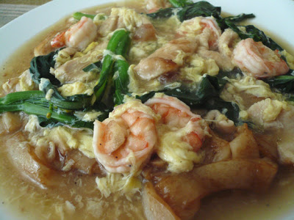

Original recipe and Ingredients:

1 small packet of fresh flat noodles (kueh tiow/hor fun)  
1 piece of chicken breast - slice thinly and marinate with some cornstarch and soy sauce  
10 medium size shrimp  
1 bunch of greens - any kind (I used mustard green/sawi)  
2 cloves of garlic  
3 cups of chicken stock or water  
2 tbsp of oyster sauce  
2 tbsp of soy sauce  
1 egg - lightly beaten  
Salt & pepper to taste  
corn starch solution - for thickening the gravy

1) Put about a tbsp of oil in a non stick pan and stir fry the flat noodles with soy sauce until its warm and slightly brown. Remove and set aside.

2) Put some oil to the frying pan and add in the garlic and stir-fry until lightly brown. Add in the marinate chicken. Stir fry of a minute and add in the water or chicken stock. Add in oyster sauce, soy sauce. Bring it to boil.

3) Add in greens and shrimps. Continue to cook for 2 minutes and check seasoning. Add in cornstarch solution to the thickness you want. Bring it to boil.

4) Turn off the heat and stir in beaten egg. Gently stir to cook the egg.

5) Dish the gravy over the fried noodle and serve warm with pickle green chillies.

Own recipe: Flat noodle (Wat Tah Hor)

Ingredient:

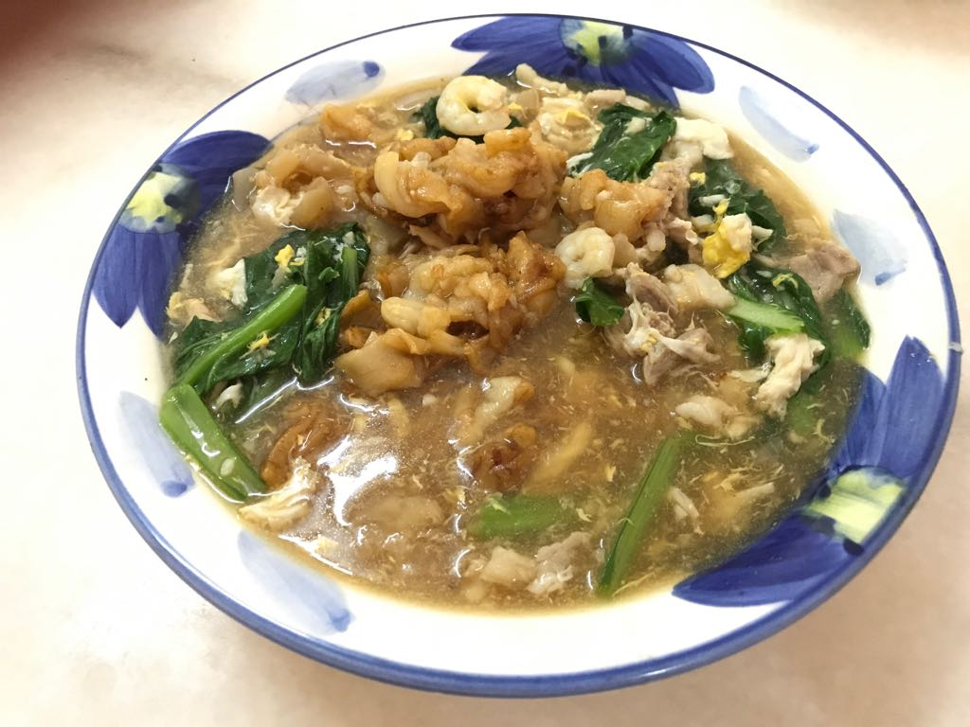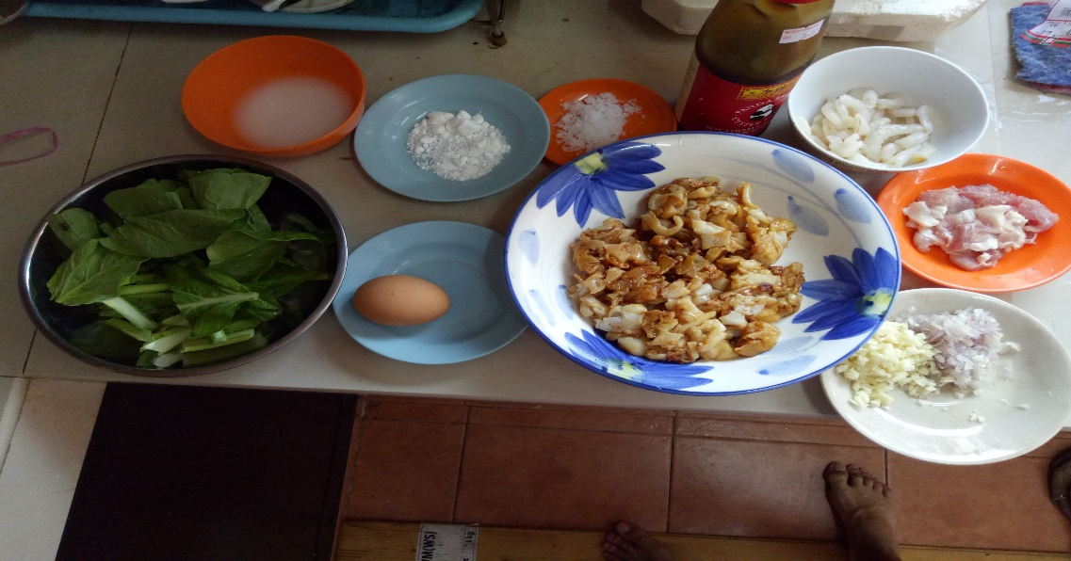

Ingredients:

Kyaw Teow (flat noodle) – half pkt

Chicken meat – 5 g

Prawn – 5 pcs

Egg – 1 nos beaten

Bok choy (vegetable)– 6 g

Salt – 1 small spoon

Oyster oil – 2 spoon

Potato starch – 25 g with some water

MSG – 1 small spoon

Directions:

1) Put about a tbsp of oil in a non stick pan and stir fry the kway teow with soy sauce until its warm and slightly brown. Remove and set aside.

2) Put some oil to the frying pan and add in the garlic, onion and stir-fry until lightly brown.

Add in the marinate chicken. Stir fry of a minute and add in the water or chicken stock. Add in oyster sauce, soy sauce. Bring it to boil.

3) Add in Bok Choy and prawn. Continue to cook for 2 minutes and check seasoning. Add in potato starch solution to the thickness you want. Bring it to boil.

4) Turn off the heat and stir in beaten egg. Gently stir to cook the egg.

5) Dish the gravy over the fried kyaw teow and serve warm with red chili.

(ii) Indian Cuisine

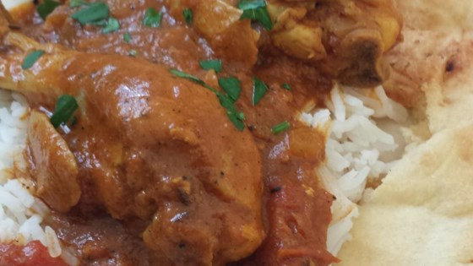

Original Ingredient and recipe:

1 pound skinless, boneless chicken breast halves - cut into bite-size pieces

1 tablespoon fresh lemon juice

salt and pepper to taste

3 tablespoons olive oil

1 teaspoon cumin seed

1 large onion, finely chopped

2 cloves garlic, minced

1 teaspoon minced fresh ginger

1 (8 ounce) can peeled, chopped tomatoes

1 teaspoon chili powder

1/2 teaspoon ground turmeric

1 teaspoon garam masala

1/2 teaspoon ground cumin

1 pinch ground coriander

1/2 teaspoon paprika

3 tablespoons plain yogurt

2 medium potatoes, peeled and cut into 1 inch cubes

1 1/2 cups water

1 (5.5 ounce) can tomato juice

fresh chopped cilantro, for garnish

Direction:

In a large bowl, toss the chicken pieces with lemon juice, salt, and pepper to coat. Set aside.

Heat oil in a large, heavy saucepan over medium heat. Stir in cumin seed and cook 1 minute, until lightly toasted. Mix in onion, garlic, and ginger. Cook until onion is tender. Add tomatoes, and season with chili powder, turmeric, garam masala, ground cumin, coriander, and paprika. Continue to cook and stir 2 minutes.

Mix yogurt into the saucepan until well blended. Add chicken pieces, and potatoes. Mix in water and tomato juice. Reduce heat to medium-low. Cover and simmer about 40 minutes. Adjust seasonings to taste and garnish with fresh cilantro before serving.

Own recipe: Curry Chicken

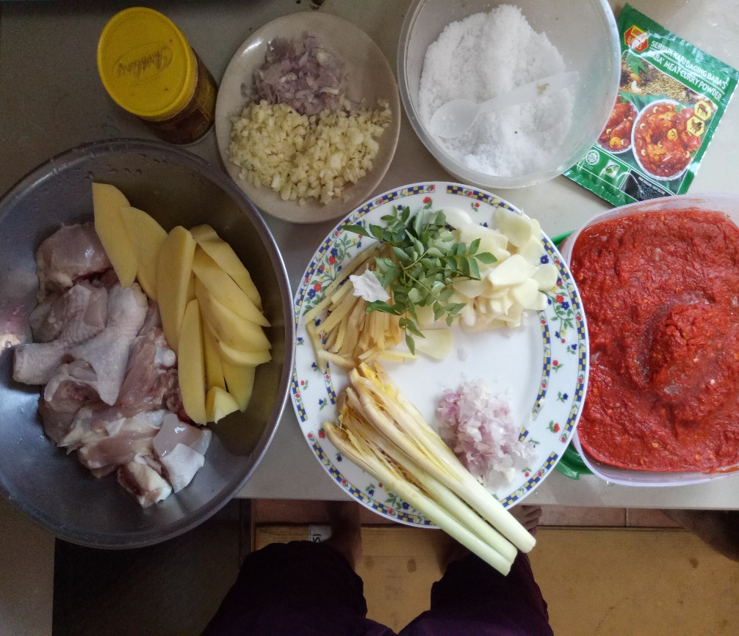

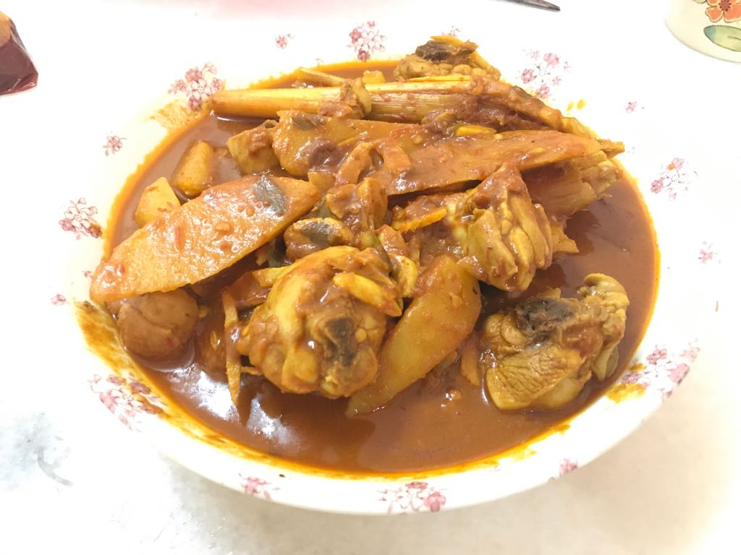

Ingredients:

Chicken legs - 3 pcs

Potato cube – 2 grain

Ginger – 5 g

Garlic slice - 5 g

Onion (chopping) – 3 g

Lemongrass (cut cube)– 4 pieces

Curry leaves – 2 bunch

Curry powder – 1 pkt

Sambal – 2 big spoon

Yellow ginger powder – 1 small spoon

SMG – 1 small spoon

Salt – 1 small spoon

Directions:

Marinate the chicken with fresh ginger garlic paste, turmeric powder and salt.

Set it aside in the refrigerator for at least 1 hour

Meanwhile, take a heavy bottom pan and add all the garlic, chopping onion, ginger and lemongrass under 'Dry Roast' and keep stirring for 5-8 minutes.

Put three pieces of chicken legs chicken legs in a pan and add 2 grain of potato cube cook until broil.

Heat some water in a pan and add curry leaves and season with salt and MSG, after that put the curry powder one packet and one small spoon of yellow ginger powder, last one put two big spoon of sambal.

Cover the pan steam until the curry sauce boiling and spice.

(iii) Western Cuisine

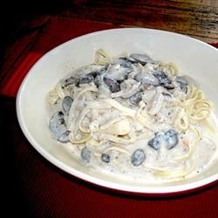

Original ingredient and recipe:

1 (12 ounce) package dry fettuccine noodles

1 tablespoon olive oil

1 tablespoon butter

4 fresh mushrooms, sliced

1 tablespoon minced garlic

1 tablespoon Italian seasoning

1 teaspoon salt

1/2 cup white wine

1 cup chicken stock

1/2 cup sour cream

1 tablespoon cornstarch

1/4 cup grated Parmesan cheese for topping

Directions:

Bring a large pot of lightly salted water to a boil. Add pasta and olive oil. Cook for 7 minutes, or until tender Drain.

Meanwhile, melt butter in a skillet over low heat. Add the mushrooms, and cook until soft and dark. Stir in the garlic, Italian seasoning, salt, white wine, and chicken broth. Increase the heat to medium, and cook stirring constantly for about 5 minutes.

Reduce heat to low, and stir in the sour cream until smooth. Stir in cornstarch, and simmer for a minute to thicken. Stir in pasta, or spoon sauce over pasta. Serve, and top with grated Parmesan cheese.

Own recipe : Carbonara pasta

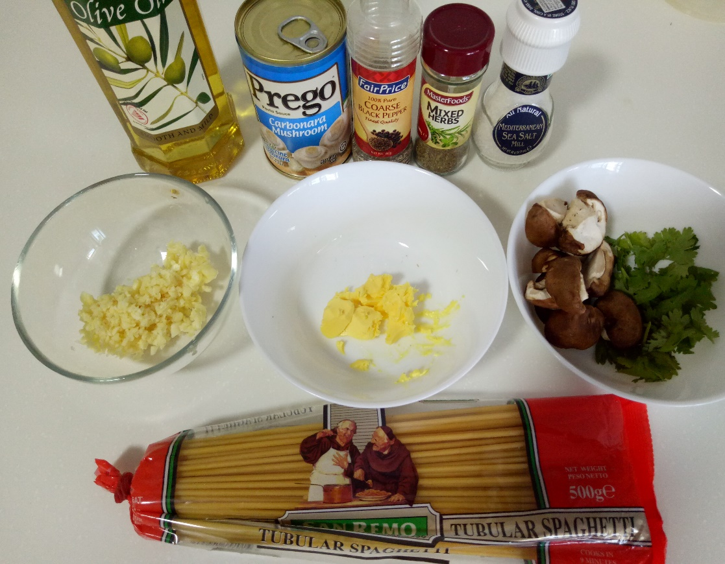

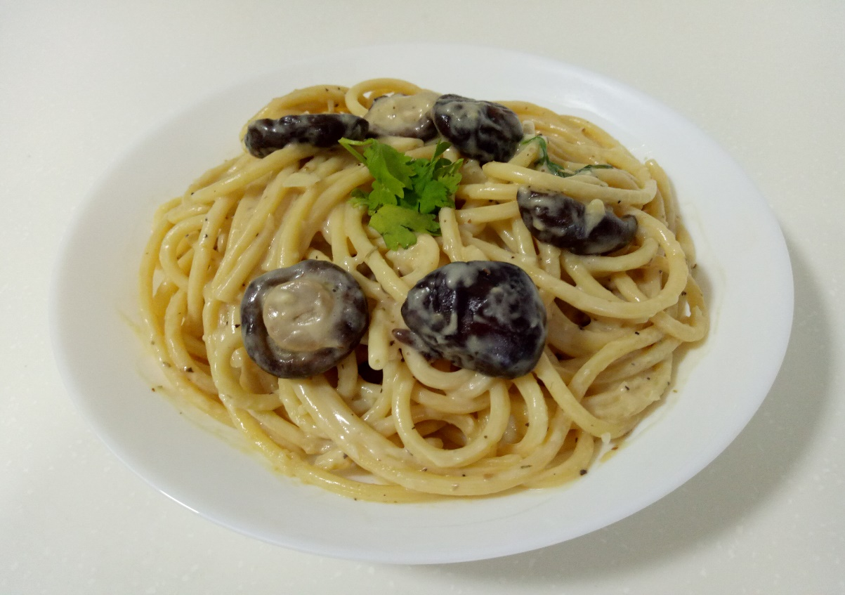

Ingredients:

Olive oil – a bit

Spaghetti – 60 g

Mushroom – 5 g

Parsley – 2 g

Butter – 3 g

Chopping garlic – 5 g

Carbonara mushroom sauce – 3 spoon

Water – 3 g

Mixed herbs powder – 2 g

Salt – 2 g

Black pepper – 2 g

Directions:

Bring a large pot of lightly salted water to a boil. Add spaghetti and olive oil. Cook for 8 minutes, or until tender Drain.

Meanwhile, melt butter in a skillet over low heat. Add the mushrooms, and cook until soft and dark. Stir in the garlic, salt, and parsley. Increase the heat to medium, and cook stirring constantly for about 5 minutes.

Reduce heat to low, and stir in the sour cream carbonara mushroom sauce until smooth. Simmer for a minute to thicken. Stir in spaghetti and put some mixed herbs powder and black pepper. Serve with some parsley on top.

**Conclusion**

I learn what is international cuisine and got to know new dishes from other country. Starting this assignment by doing this three Cuisines, it is not easy to do, because two of the Cuisines are from other country. I need to do a lot of research on examples and learn how to do it.

This assignment requires me to choose three Cuisines to do my own recipe, there’s fried flat noodle, curry chicken and carbonara pasta.

When you’re in the kitchen, you’re coming into contact with a lot of dangerous pieces of equipment. A hot oven or boiling water could easy to burn you. A slip with a sharp knife could give you a bad cut.

Always remember to work slowly and carefully in the kitchen and be aware of potential dangers.

For example, always turn pot handles sideways on the stove so you don’t walk by and tip it over. When you’re finished with a knife, either clean it and put it away or place it in the sink to be washed later. never leave a knife out on the counter. If you think you need a little help in the kitchen with chopping or taking things out of the oven, enlist the help of an adult, older sibling or friend.

**References**

By ICook4Fun, February 11, 2008. Online source, Wat Tah hor. Retrieve from: <http://www.mykitchensnippets.com/2008/02/wat-tah-hor.html>

By Simmig, Unknown date. Online source, Traditional Chicken Curry. Retrieve from: <http://allrecipes.com/recipe/80683/traditional-chicken-curry/>

By STEPH477, Unknown date. Online source, Creamy Mushroom Pasta. Retrieve from: <http://allrecipes.com/recipe/72797/creamy-mushroom-pasta>